**An application for learning Kanji by using**

**the Heisig and Spaced Repetition method**

**Thepparat Phengposop**

Submitted to the

Department of Computer Science and Information Technology

in Partial Fulfilment of the Requirements for the Degree of

Bachelor of Science in Computer Science

at the Naresuan University

November 2020

Copyright of Naresuan University. All rights reserved.

**An application for learning Kanji by using the Heisig and Spaced Repetition method**

by

**Thepparat Phengposop**

Submitted to the

Department of Computer Science and Information Technology

in Partial Fulfilment of the Requirements for the Degree of

Bachelor of Science in Computer Science

**Committee**

……………………………….........………...........................Advisor

(Associate Professor Antony Harfield, Ph.D.)

……………………………….........………...........................Committee Member

(Duangduen Asavasuthirakul, Ph.D.)

……………………………….........………...........................Committee Member

(Wansuree Massagram, M.S.)

…………………………….........………................................…

(Assistant Professor Sanya Khruahong, Ph.D)

Head of Department of Computer Science and Information Technology

November 6, 2020

# Acknowledgement

This endeavour would not have been possible without my committee chair, Assistant Professor Dr Antony Harfield, who consistently and effectively conveyed an effectively expressed excitement for teaching as well as a spirit of exploration when it came to research. This dissertation would not have been possible without his direction and persistent support.

Special thanks to Assistant Professor Dr Duangduen Asavasuthirakul and Assistant Professor Dr Wansuree Massagram who participated in the validation survey for this research. This research could not have been successfully completed without their passionate participation.

Lastly, I would like to mention my family, especially my parents. Their trust in me has kept me motivated and positive through this whole project.

Thepparat Phengposop

**Title** An application for learning Kanji by using the Heisig

and Spaced Repetition method

**Author** Thepparat Phengposop

**Student ID** 62312187

**Advisor** Associate Professor John Smith, Ph.D.

**Co-advisor** Jane Doe, Ph.D.

**Academic Paper** Undergraduate Thesis B.S. (Computer Science)

Faculty of Science, Naresuan University

**Keywords** Mobile application, kanji, Heisig, Spaced repetition

# Abstract

The purpose of the project is to enable students learning Japanese to memorise Kanji with increased efficiency. The learners can learn kanji with the Heisig method through the story of the kanji component. After the learners finish the memorization, the learner can repeat the memorization with the Spaced repetition method by space the repeat time. This project combines the advantages of both strategies helps the learners to reduce the unnecessary review time, improve the efficiency of memorization and keep long term memory.

# Table of Contents

|  |  |
| --- | --- |
|  | **page** |
| **Acknowledgement** | i |
| **Abstract** | ii |
| **Table of Contents** | iii |
| **List of Tables** | iv |
| **List of Figures** | v |
| **Chapter 1 Introduction**   * 1. Introduction   2. Objectives   3. Scope   4. Assumptions   5. Definitions   6. Benefits | 1  1  2  2  2  3 |
| **Chapter 2 Literature Review and Related Works**  2.1 Background  2.1.1 Theory  2.1.2 Technique  2.1.3 Technology  2.2 Related Works | 4  4  5  6  8 |
| **Chapter 3 Methodology**  3.1 Method  3.3 Design and Implementation  3.4 Testing | 9  11  13 |
| **Chapter 4 Results and Discussion**  4.1 Results  4.2 Discussion | 14  18 |

# Table of Contents (cont.)

|  |  |
| --- | --- |
|  | **page** |
| **Chapter 5 Conclusions**  5.1 Conclusions  5.2 Limitations  5.3 Recommendations | 19  19  20 |
| **References** | 21 |
| **Appendix**  Appendix A : Database Schema  Appendix B : Tutorial | 22  30 |

# List of Tables

|  |  |  |
| --- | --- | --- |
| **Table** |  | **page** |
| 2.1 | Table name | 5 |
| 2.2 | xxxxxxxxxxxxxxxxxxxxxxxxx | 10 |
| 3.1 | xxxxxxxxxxxxxxxxxxxxxxxxx | 11 |

# List of Figures

|  |  |  |
| --- | --- | --- |
| **Figure** |  | **page** |
| 2.1 | xxxxxxxxxxxxxxxxxxxxxxxxx | 2 |
| 2.2 | xxxxxxxxxxxxxxxxxxxxxxxxx | 3 |
| 3.1 | xxxxxxxxxxxxxxxxxxxxxxxxx | 4 |

# Introduction

## Introduction

Currently, learning a second or third language is highly beneficial, but it comes with some obstacles, especially kanji in Japanese because kanji have too many characters, stroke order, different types of reading and hybridised words.

Kanji can be learned in a different method, such as by writing books and flashcards or by repeatedly writing or reading kanji; nevertheless, learning kanji takes a very long period to understand and memorise.

The main aim of this project is to create an application to improve the efficiency of memorization and cut short unnecessary time for learners who have a little leisure time to learn kanji. I have chosen two techniques that researchers have proposed but that do not have technological support. The first technique enables learners to use imagination to learn kanji through a story based on the kanji component's meaning via Heisig method. This is combined with the second technique that spaces the repeat time to focus on kanji which are still hard to recall without spending time in reviews that aren't necessary via the Spaced repetition method. I plan to implement these two techniques together in a mobile application that can measure learner progress.

## Objectives

1. To help the learners to improve memorization efficiency.
2. To reduce unnecessary review time.
3. To help learners in increase information recall over a longer period of time.

## Scope

This application, we are concerned with the Kanji Alive API for getting data on Japanese kanji that supports about 1200 kanji which are taught in Japanese elementary schools and are included in the kanji lists of JLPT up to N2. Users of this application are for those wanting to utilize kanji for employment or scholarships abroad.

## Definitions

**Kanji** [1] is a type of Japanese writing system, based on symbols which represent words or ideas. Kanji can be combined to form a word, or can represent a word itself. It was originally founded on logographic Chinese characters.

**JLPT** [2]is the largest Japanese-language test in the world to measure and certify the Japanese-language proficiency of those whose native language is not Japanese. The use of JLPT results has expanded from skill measurement to include employment screening and evaluation for promotions and pay raises as well as use as a form of qualification. The JLPT has five levels: N1, N2, N3, N4 and N5. The easiest level is N5 and the most difficult level is N1.

**Heisig** [3] is the method of learning kanji by rote memorization. Heisig invites us to create short story plots using as elements of the plots the parts that make up the kanji that we are learning.

**Spaced Repetition** [4] is a learning strategy where lessons are repeatedly reviewed at increasing intervals to ensure that important lessons are unforgettable.

**OkHttp** [5] is a third-party library developed by Square for sending and receiving HTTP-based network requests.

**Retrofit** [6] is a type-safe REST client for Android, Java and Kotlin developed by Square. The library provides a powerful framework for authenticating and interacting with APIs and sending network requests with OkHttp.

**Gson** [7] is a simple Java-based library to serialize Java objects to JSON and vice versa. It is an open-source library developed by Google.

## Benefits

By only analyzing the kanji that really is necessary, this application cuts down on the time spent reviewing kanji.

By learning or creating a kanji story with kanji component, the application improves the efficiency of memorization.

To allow learners to concentrate on a kanji they are already having a hard time remembering.

To enable learners to track and make progress within those simple and quick ways.

# Literature Review

## Background

The data in this project was obtained through the Kanji Alive API using Retrofit [6]. And we configure converter Gson [7] to serialize and deserialize objects to and from JSON. For making HTTP requests Retrofit uses the OkHttp library [5]. Retrofit is a high-level REST abstraction build on top of OkHttp. As shown in below.

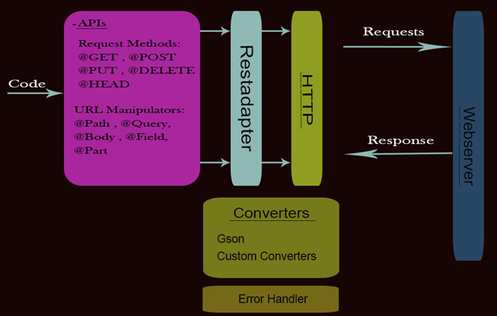

Figure . principle of Retrofit library

The architecture in Figure 2.1 that we choose in this project is MVVM architecture. This architecture helps to completely separate the business and presentation logic from the UI, and the business logic and UI can be clearly separated for easier testing and easier maintenance.

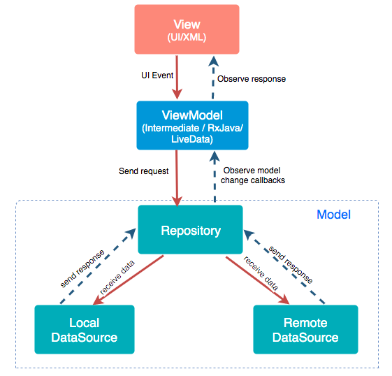

Figure . MVVM architecture

MVVM stands for Model, View, ViewModel.

**Model** used to hold the data of the application. It cannot directly talk to the View. Generally, it’s recommended to expose the data to the ViewModel through Observables.

**View** represents the UI of the application devoid of any Application Logic. It observes the ViewModel.

**ViewModel** acts as a link between the Model and the View. It’s responsible for transforming the data from the Model. It provides data streams to the View. It also uses hooks or callbacks to update the View. It’ll ask for the data from the Model.

## Related Works

Nowadays there are many projects and researches that related to learning and memorizing. Spaced repetition [4] is the most often used technique. This strategy has been used widely to assist learners recall items other than Japanese kanji [1]. for example, vocabulary from various languages or topics being studied as shown in Figure 2.3, Figure 2.4 and Figure 2.5..

First is **Card-based design combined with spaced repetition: A new interface for displaying learning elements and improving active recall** [8]

a mobile application called “English Practice” has been developed wherein a card-based interface named PACARD (Personalize Adaptive CARD-based interface) was implemented. The application three Components, that allows users to check their study progress via a function called “Daily Test”. Daily Test is designed to offer learners a chance to test what they have learned in the previous and do not allow learners to view hints, comments, or use support tools. Practice module, a learner enters Quiz to do some practice with multi-choice questions, after learners switch to Flashcard, set to check on some vocabulary and then goes to Note function to create a note. Afterward enters the PACARD module works as learning assistance that tracks and represents everything in card format for conventional reviewing. According to the spaced repetition [4] concept.

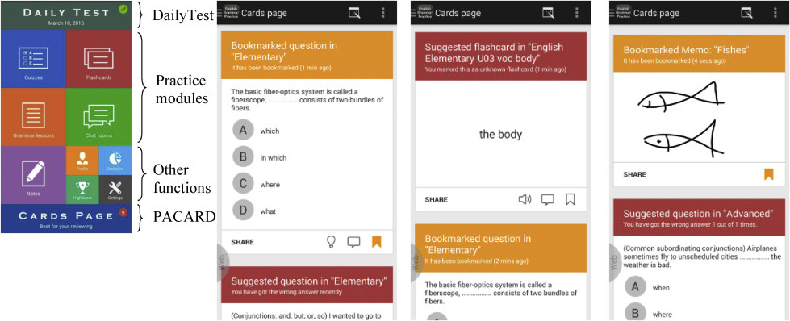

Figure . English Practice Application

**Next is Anki** [9] **which** is a program that has a lot more efficient than traditional study methods, you can either greatly decrease your time spent studying, or greatly increase the amount you learn. that can make your own flashcards with text, sound, and images then you can study with flashcards that you pre-written and take time to consider and analyse with your answer after finish study Anki use Spaced Repetition to review the flashcards with the answers you have evaluated. Anki coming with a flexibility and useful feature such as config your study method or type of flash card.

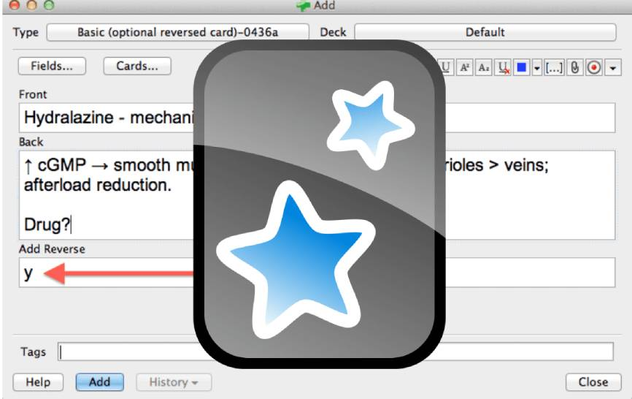

Figure . Anki Application

**A Conceptual Design of Kanji Mobile Application with Augmented Reality Technology for Beginner**

Kanji mobile application with Augmented Reality technology that suitable for the students who no Japanese background, never taken any level of JLPT test. helps to enhance learning though motivation. Application display in three dimensions animation with Augmented Reality Technology. And another feature is stroke order animation, pronunciation and translate

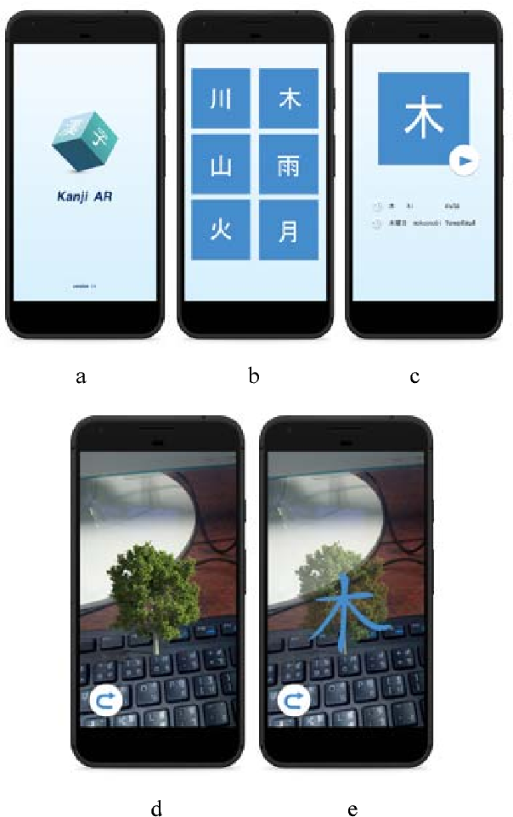

Figure . Kanji mobile application with Augmented Reality

# Methodology

## Method

### Tools

Android Studio is one of the tools we use for this project. Android Studios is the official IDE for Android (Integrated Development Environment). Additionally, Android Studio has a ton of helpful features, like a fast and feature-rich emulator, a layout editor, and more. The main reason is Android studio also support Kotlin, which is the language we're using with this project. We chose it because it's recommended for Android app developers, and then another reason is that Kotlin will get new features first.

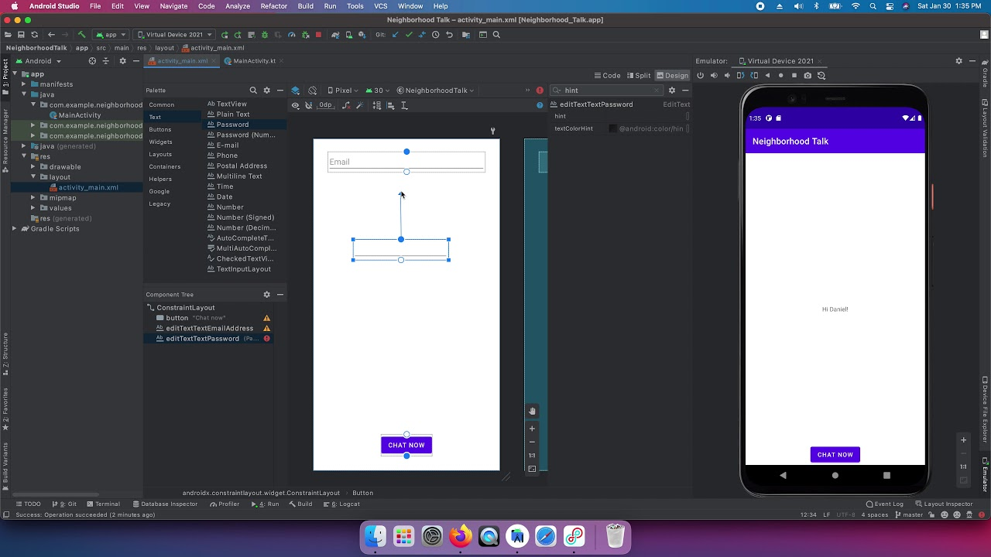

Figure . Android Studio

For database in this project we use Room Database because Room is a part of the Android Architecture components which provides an abstraction layer over SQLite which allows for more robust database access while still providing the full power of SQLite. There are basically three major components in Room:

1.[Data entities](https://developer.android.com/training/data-storage/room/defining-data) Representation of table and columns in your app's database.

2.Data access objects (DAOs) that provide methods that your app can use to query, update, insert, and delete data in the database.

3.The database class that holds the database and serves as the main access point for the underlying connection to your app's persisted data.

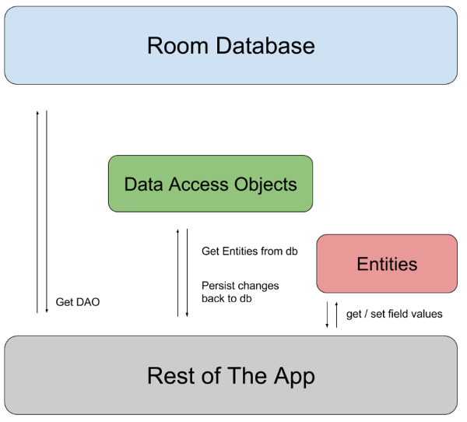

Figure .  Diagram of Room library architecture.

The next tool, Postman, allows us to test the Kanji Alive API without having to write a ton of code. In this project, we use Postman to send and receive requests data from the server.

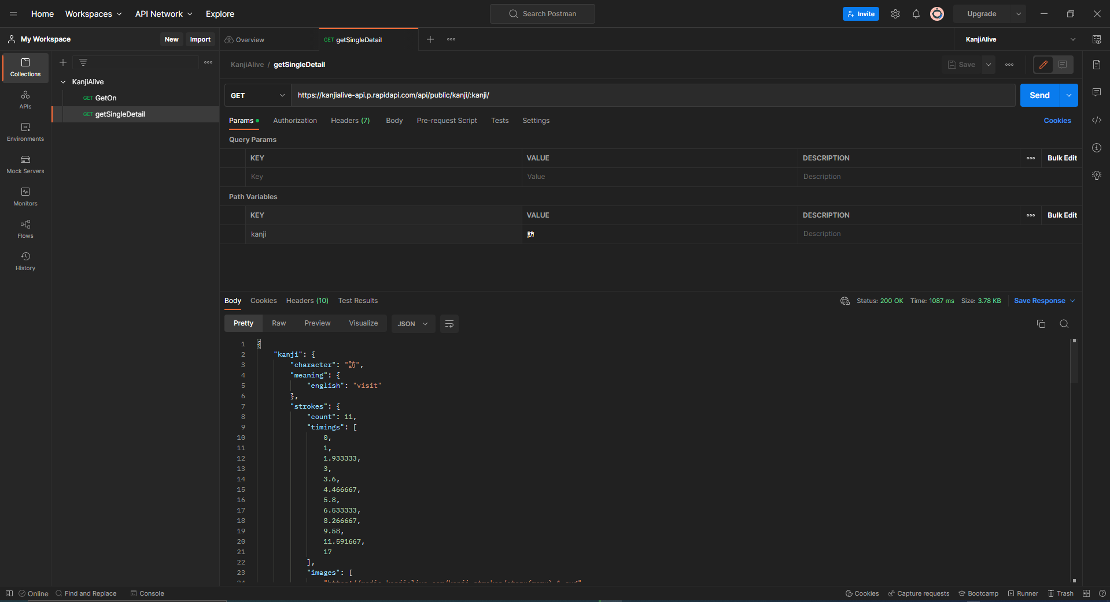

Figure . Postman API test case

### Steps

This development is conceptualized using the scrum model in agile operations. Sprint Planning is the first step, then we discussed with an advisor about the features of the application. After received the wish list, we breakdown the features into tasks that we're going to complete one by one. The next step is Sprint Backlog, we assign task that we done in the first step in to the sprint. The next step is Sprint Review, we generally discuss our progress every week and during a Sprint Review with an advisor to determine what we done, what should be adjusted and what should be achieved the following week until everything on the wish list has been completed.

## Design and Implementation

### Design

I begin with designing a user flow before I start developing the application to help in process design and understanding from the perspective of the learner. I decide to split the development into 3 major parts: a Heisig part, a spaced repetition part and a stat part.



Figure . user flow

And we also need Entity Relationship Diagram for Room database.

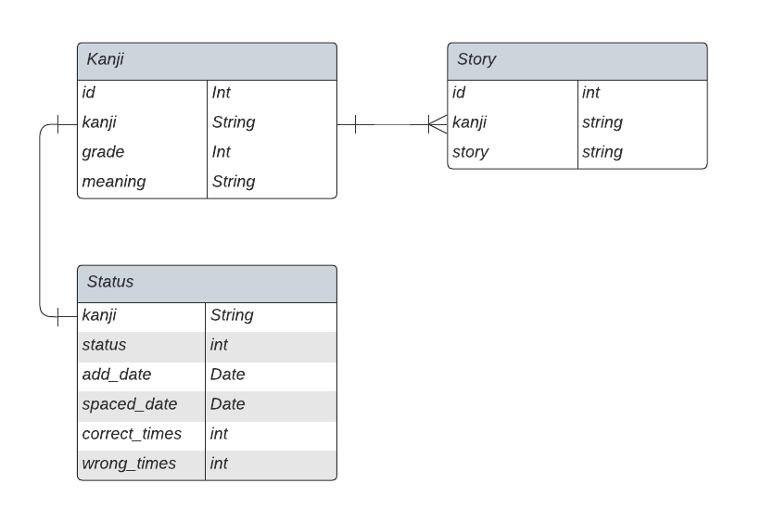

Figure . Kanji’s Entity Relationship Diagram

### Implementation

**Heisig part of the learning path allows learners to select a category of kanji and a particular kanji within that category before learning the kanji via Heisig method. They can click the heart button on right top of the screen to add the kanji to the spaced repetition part if they want to employ the spaced repetition method with that kanji. I began by using Retrofit2 to submit a request to receive the kanji data in this part, and then created a room data base for use insert, update and delete methods with Heisig story and retain the data for review with the spaced repetition part.**



Figure . Heisig part

**Spaced Repetition part** This part has 6 state (Start, 1 day, 3 days, 1 week, 1 month, 6 months) after switching to Space repetition mode, learners can press the green button at specific times, students can begin repeating the memorized material by using the data that added in Heisig part.



Figure . Spaced Repetition part

**Spaced Repetition method** after finish the quiz we need to set notification and update our data. The algorithm of this method isIf the learner answers correctly, the kanji will move towards the next step until finish. If they answer incorrectly, the kanji will go back to the first step.

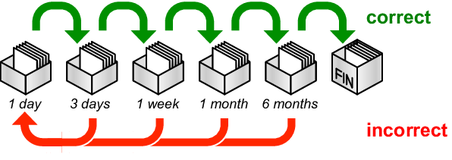

Figure . **Spaced Repetition method**

**Stat part** after learners finish the spaced part, learners can see their own progress through Stat part.



Figure . stat part

## Testing

I start test the application on October 7–13, 2022, with five individuals who had never learnt kanji before. I utilized a Google Form after the test to collect user feedback. looks the survey's results at Chapter 4.

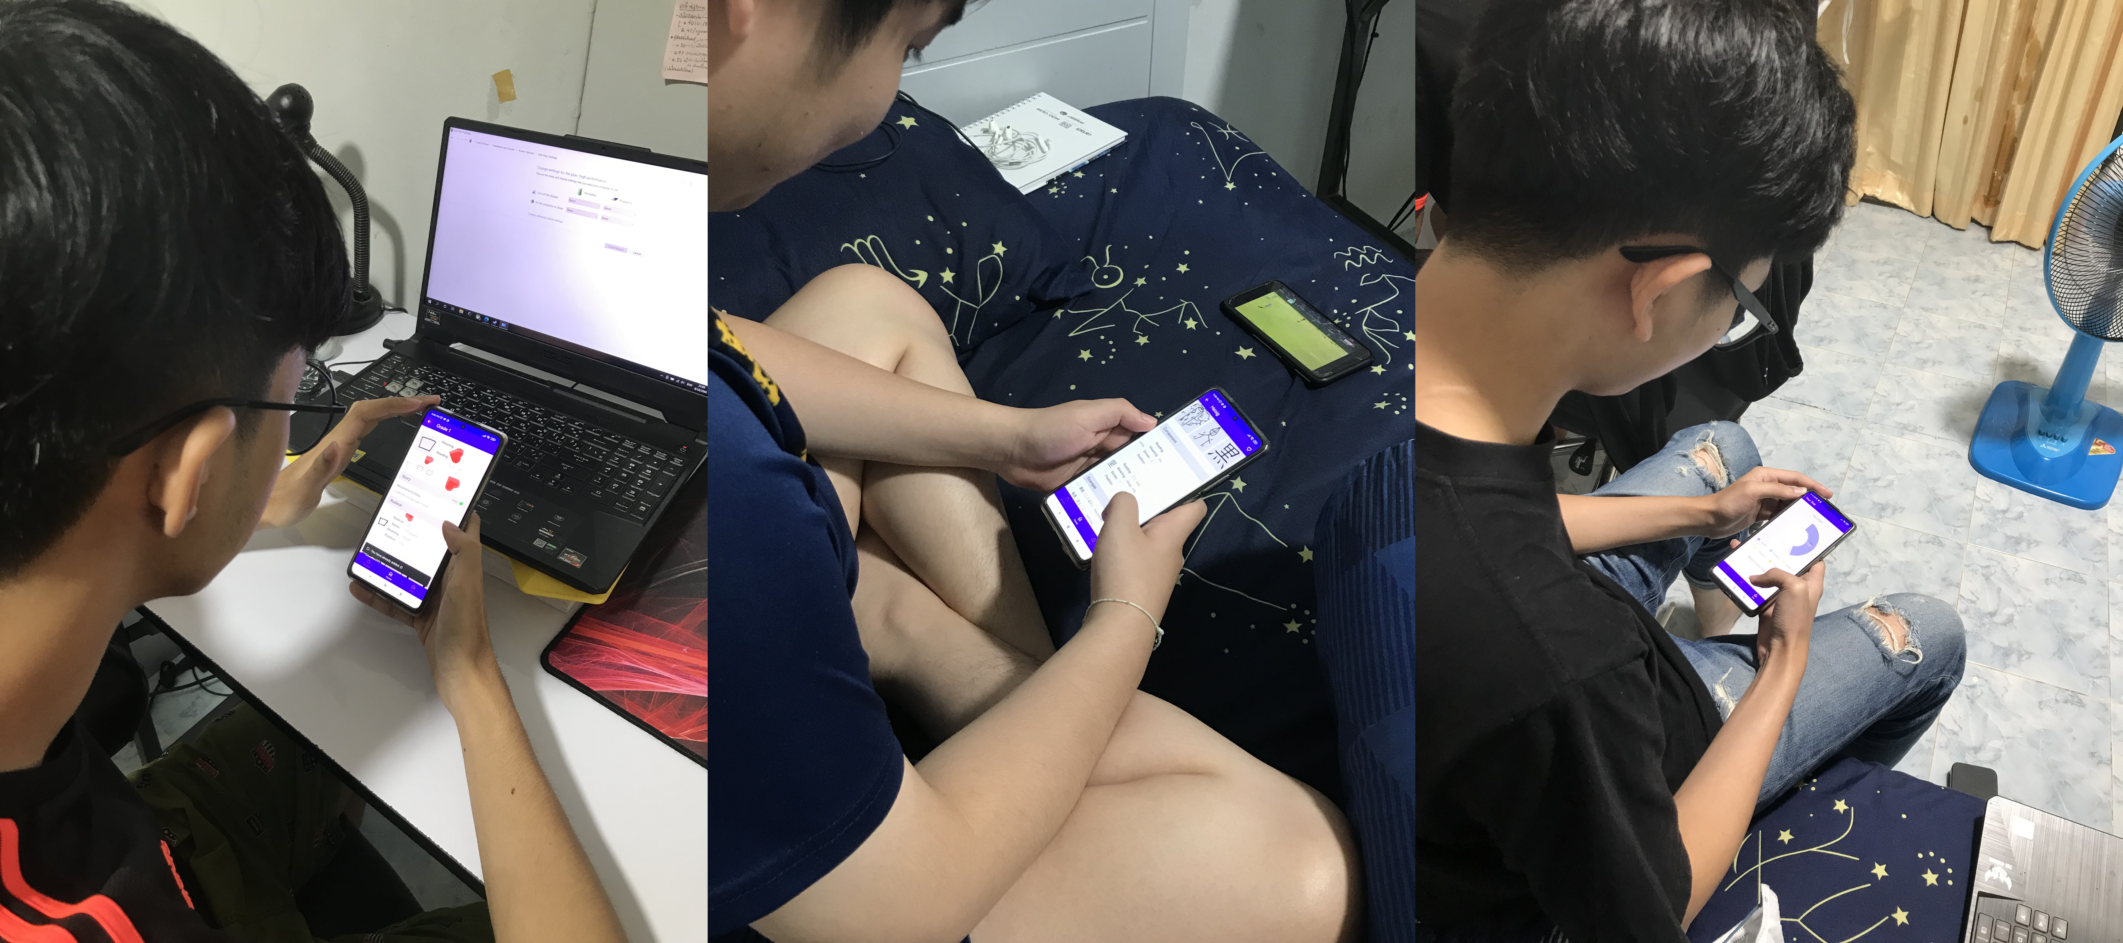

Figure .

# Results and Discussion

## Results

Table 4.1 shows the satisfaction results from the Google Form survey.

Table 4.1 Summary of the questionnaire

|  |  |
| --- | --- |
| **Question** | **x̅** |
| How satisfied are you with the speed of application? | 4.4 |
| How satisfied are you with the ease of use? | 3.8 |
| How satisfied are you with the information's accuracy? | 4 |
| How satisfied are you with the user interface? | 3.2 |

From Table 4.2, it can be seen that in a period of 1 week, 5 students can learn Kanji on average 19.2 Kanji.

Table 4.2 Summary from testing

|  |  |  |  |  |  |
| --- | --- | --- | --- | --- | --- |
|  | **Thai** | **Pay** | **Palm** | **Mark** | **Sprite** |
| **start** | 1 kanji | 2 kanji | 4 kanji | 4 kanji | 1 kanji |
| **1 day** | 7 kanji | 13 kanji | 2 kanji | 4 kanji | 3 kanji |
| **3 days** | 10 kanji | 8 kanji | 6 kanji | 2 kanji | 4 kanji |
| **1 week** | 1 kanji | 4 kanji | 2 kanji | 10 kanji | 8 kanji |
| **1 month** | - | - | - | - | - |
| **6 months** | - | - | - | - | - |
| finish | - | - | - | - | - |
| overall | 19 kanji | 27 kanji | 14 kanji | 20 kanji | 16 kanji |

## Discussion

From the results, the objectives have been achieved and that the application has helped learners memorize an average of 19 kanji in one week. The advantages of this program are the short learning period and quick memorization of kanji meaning, small amount of time to learn and the long term memorize However there are some limitations in this application is the Heisig method only help learners to memorize only the meaning of the kanji.

# Conclusions

## Conclusions

Summarise the main outcomes of the project. Explain any challenges.

This project is the combination of two methods, Heisig is the leaning kanji strategy to improve the speed of memorize but it had some disadvantage in this method is the long term memorizing so I use Spaced Repetition method to improve the efficiency. To making this project you have to research how to learn about the kanji.

## Limitations

the limitations of the project are:

1. Heisig method don't help to learn how to read kanji.

2.Spaced Repetition method required a long-term commitment.

## Recommendations

For Spaced Repetition part, it can improve about quiz by add variety to questions and Heisig part can add more option for create story with audio or picture.

# References

[1] “Kanji - Japanese Dictionary Tangorin.” https://tangorin.com/kanji (accessed Oct. 14, 2022).

[2] “What is the Japanese-Language Proficiency Test? Index | JLPT Japanese-Language Proficiency Test.” https://www.jlpt.jp/e/about/index.html (accessed Oct. 14, 2022).

[3] “Koipun - How to learn Kanji: A visual method with Heisig’s RTK.” http://localhost/blog/learn-kanji-heisig/ (accessed Oct. 14, 2022).

[4] “Spaced Repetition Promotes Efficient and Effective Learning: Policy Implications for Instruction - Sean H. K. Kang, 2016.” https://journals.sagepub.com/doi/full/10.1177/2372732215624708 (accessed Mar. 13, 2022).

[5] “Using OkHttp | CodePath Android Cliffnotes.” https://guides.codepath.com/android/Using-OkHttp (accessed Oct. 14, 2022).

[6] “Consuming APIs with Retrofit | CodePath Android Cliffnotes.” https://guides.codepath.com/android/consuming-apis-with-retrofit (accessed Oct. 14, 2022).

[7] “Gson - Overview.” https://www.tutorialspoint.com/gson/gson_overview.htm (accessed Oct. 14, 2022).

[8] X.-L. Pham, G.-D. Chen, T.-H. Nguyen, and W.-Y. Hwang, “Card-based design combined with spaced repetition: A new interface for displaying learning elements and improving active recall,” *Comput. Educ.*, vol. 98, pp. 142–156, Jul. 2016, doi: 10.1016/j.compedu.2016.03.014.

[9] “Anki - powerful, intelligent flashcards.” https://apps.ankiweb.net/ (accessed Oct. 14, 2022).

# Appendix

# Appendix A: Database Schema

# Appendix B: Tutorial

[Content starts here]